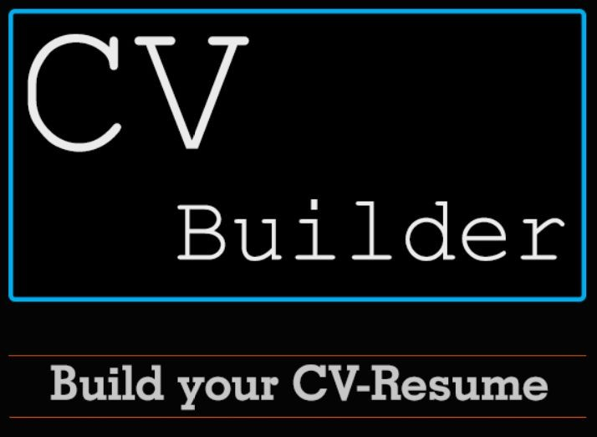

## Problem Definition

* A person who has achieved lots of achievements in his career and well reached by skills but at the time to apply for any Internship or Job, he doesn’t know how to build up my CV or Resume more attractive and creative so that I can showup my skills and knowledge to those recruiters what I have already achieved till now through only one or two page article or mostly called CV.
* So there is always one major problem with those candidates who want to apply for job but don’t know how to build my CV or Resume effective and attractive.

## Objective and End Users

* CV builder’s Objective is to give free hands to those users who want to build their own CV or Resume by just filling up details like Personal Information, Skills, Career Objective and many more in to those blanks which are provided in the application.
* Users can create new CV or Resume and they can edit it after also.
* CV builder can also suggest you to find jobs and companies related to your skills and interests which you have mentioned in Resume.
* Everyone can build CV or Resume as they need for it. So everyone are End Users.
  + Guest User

## Functionality

1. User can be able to see the difference between CV and Resume.
2. User can see the sample templates of CV and Resume in different formats.
   * Users can create CV or Resume as per their requirements of job.
   * Choose CV and Resume’s different Formats as per professions.
   * Users have to fill only details which are asked for and they can get ready copy of CV or Resume after that.
   * Users can add their photograph If they want so.
   * If user want to highlight some particular words/lines in the CV and Resume then User can be able to do that by just click some event buttons.
   * User can save PDF of CV and Resume in Drive and my account also.
   * Users can share their CV and Resume via Email or WhatsApp.
   * User will also notify for jobs and companies related to their skills and interests which they have mentioned in Resume or CV via Email.

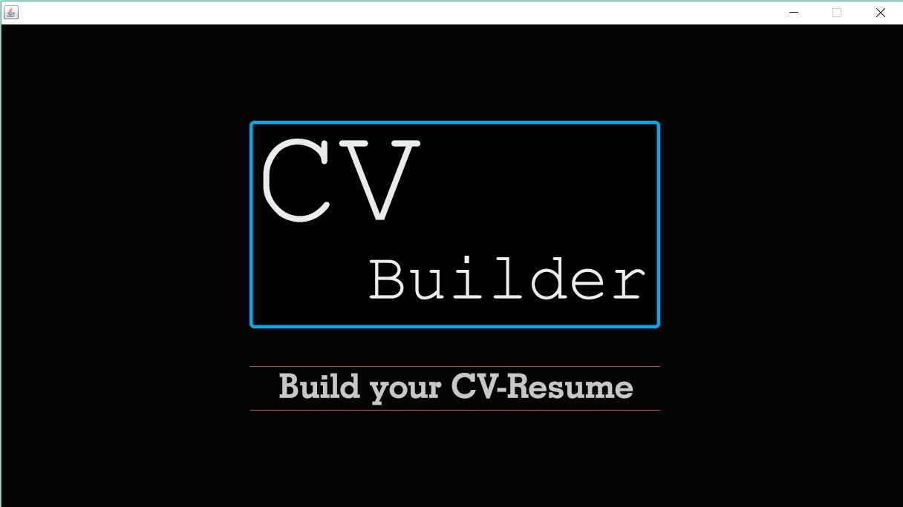**Welcome Screen :**

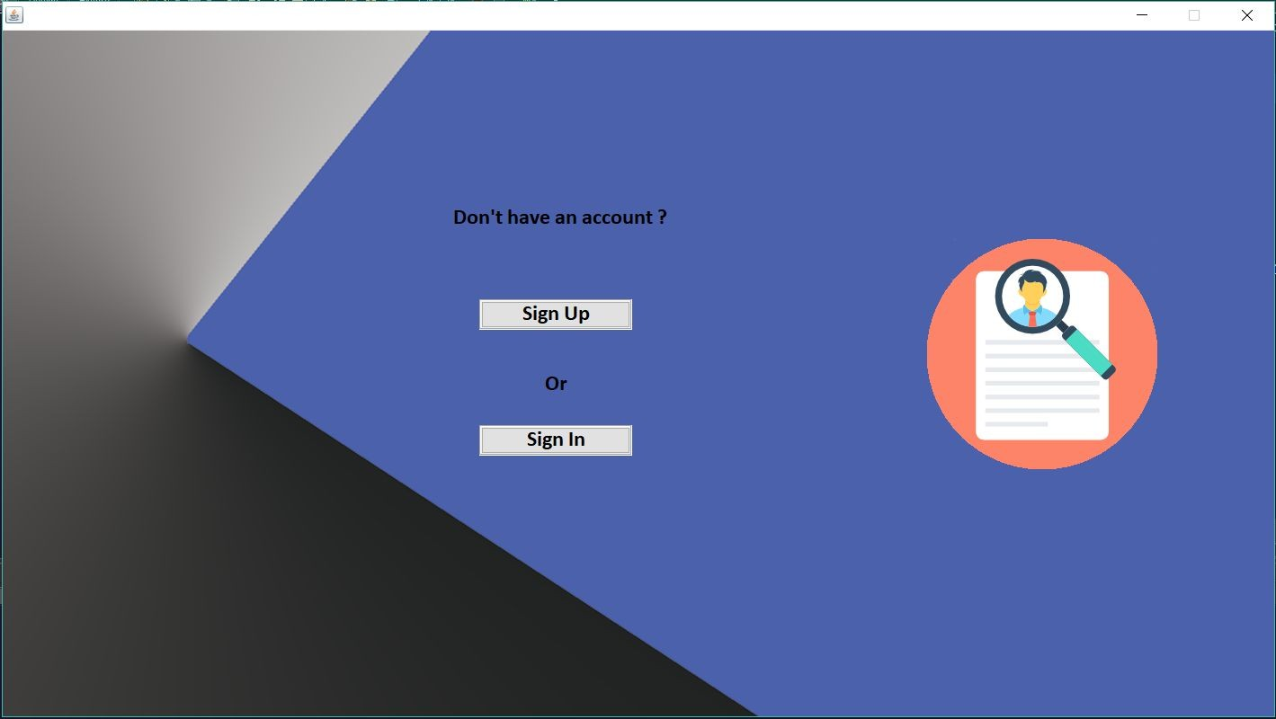**Login Register Screen**

**Register Screen :**

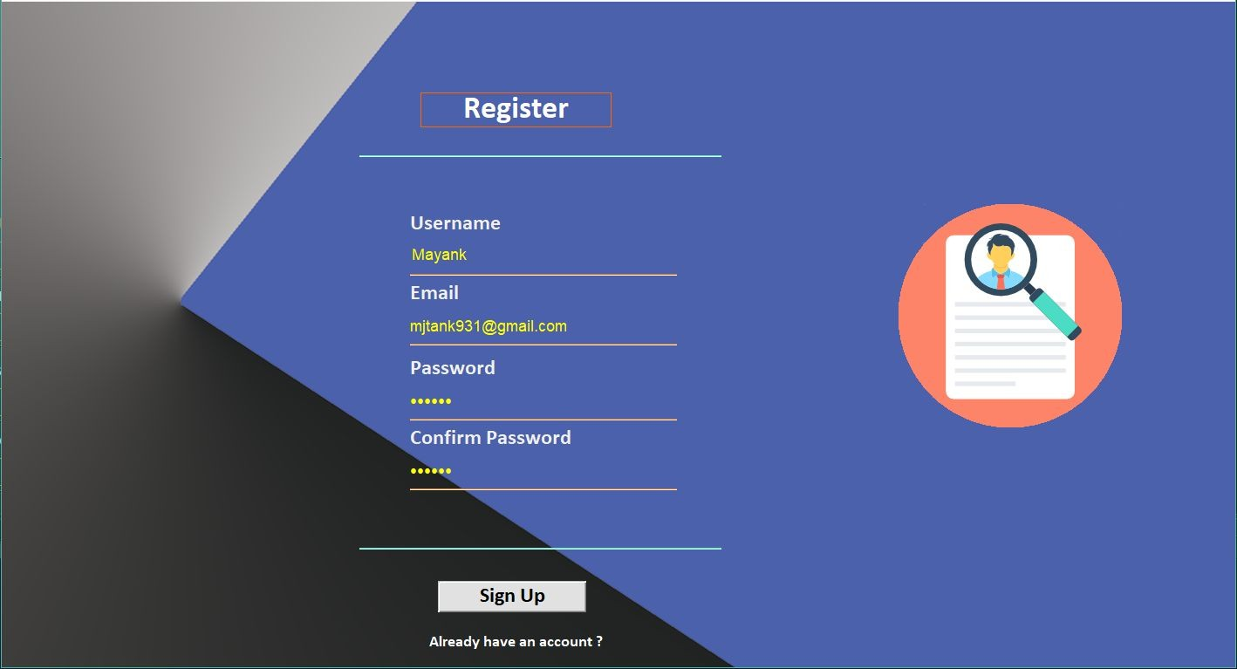

**Login Screen :**

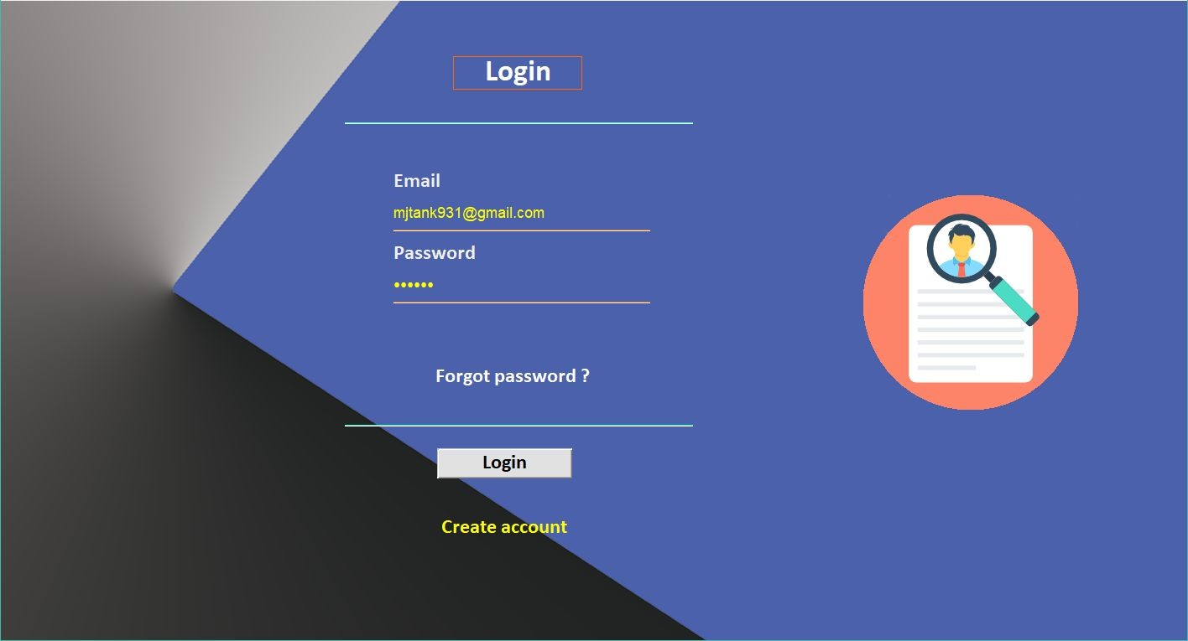

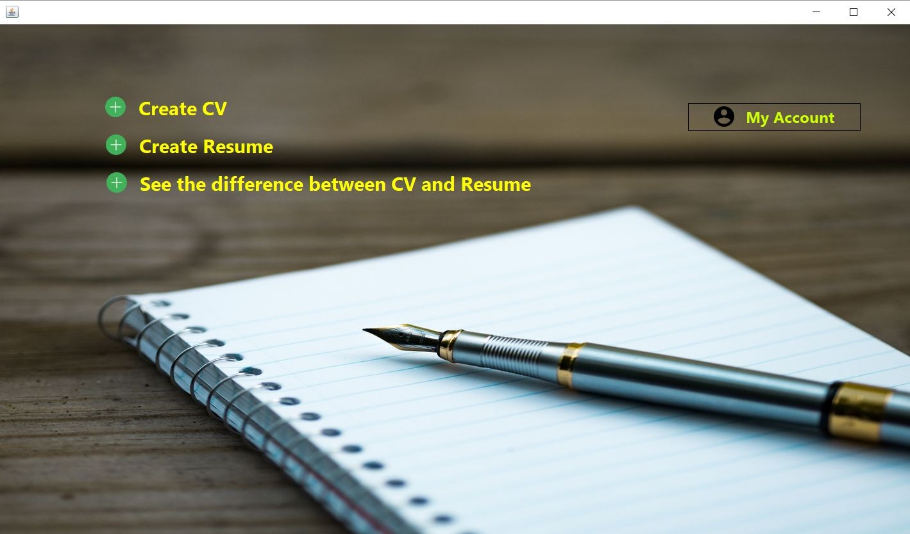**Choose your document Type (CV/Resume) :**

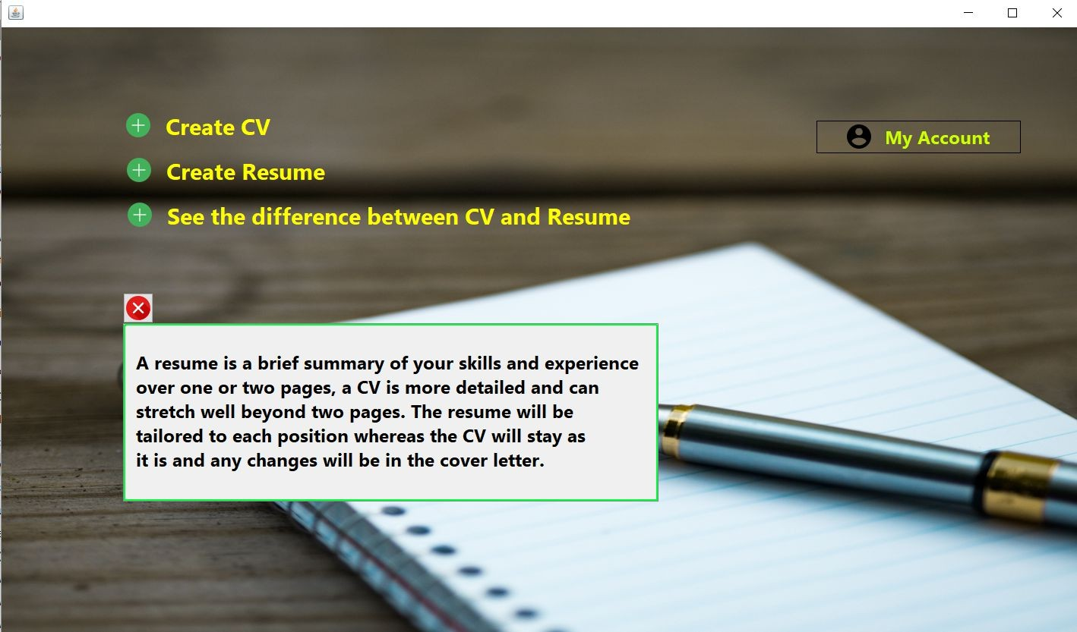

Click on my account this window will appear and user can upload a photo and find the job as per skill

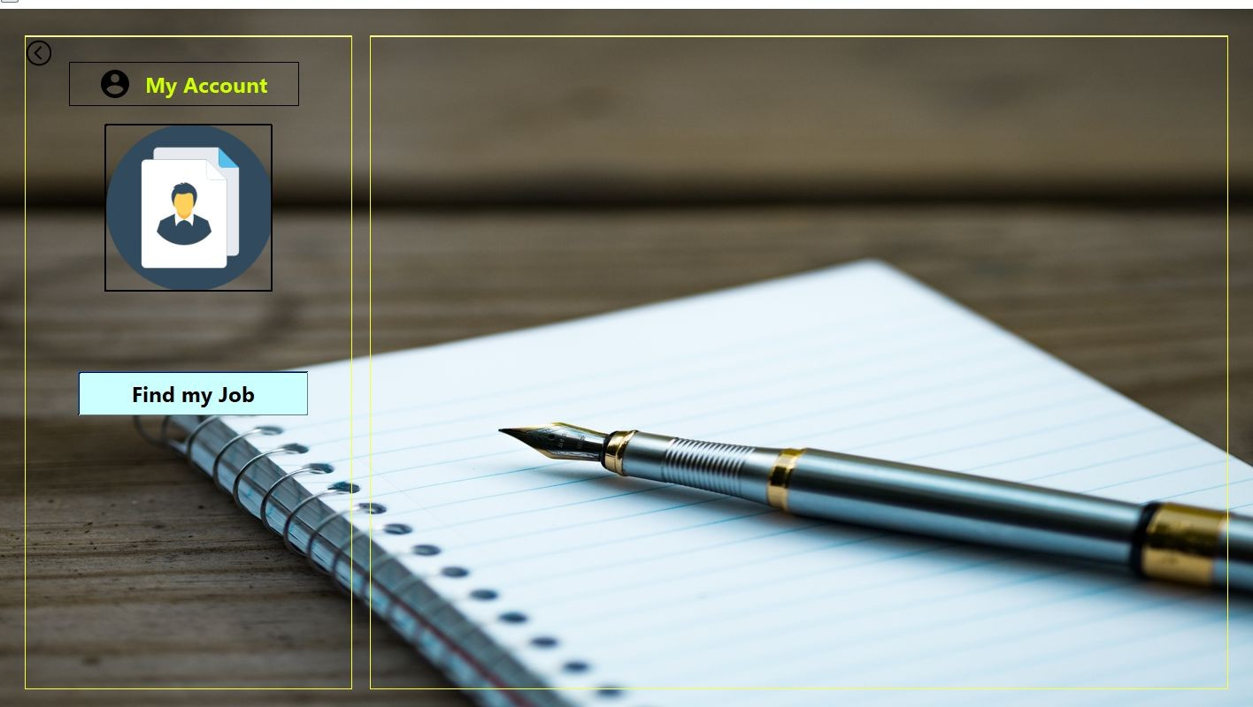

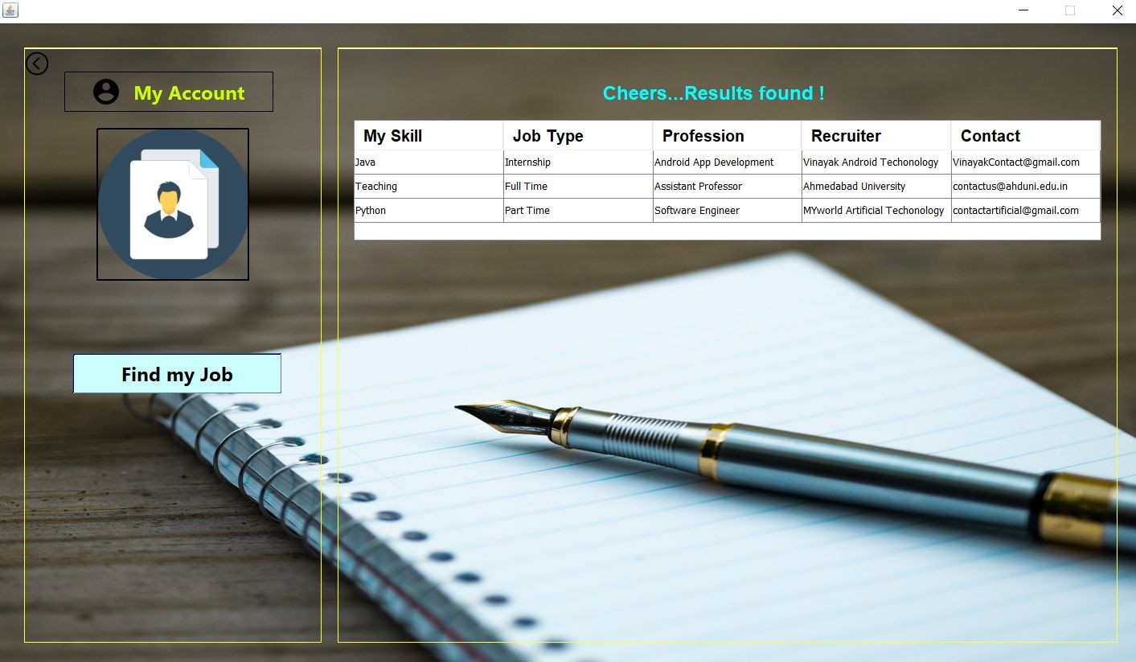

# Screens For Resume Builder



**Personal Information Screen :**

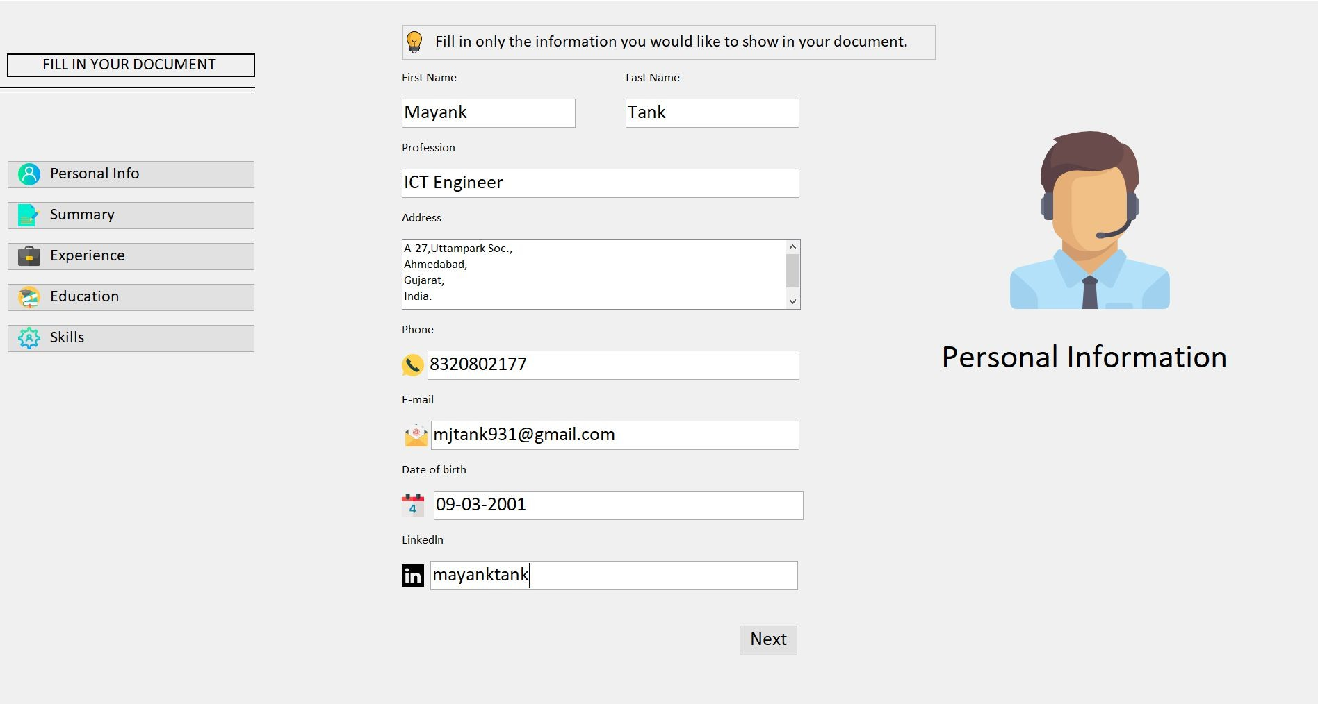

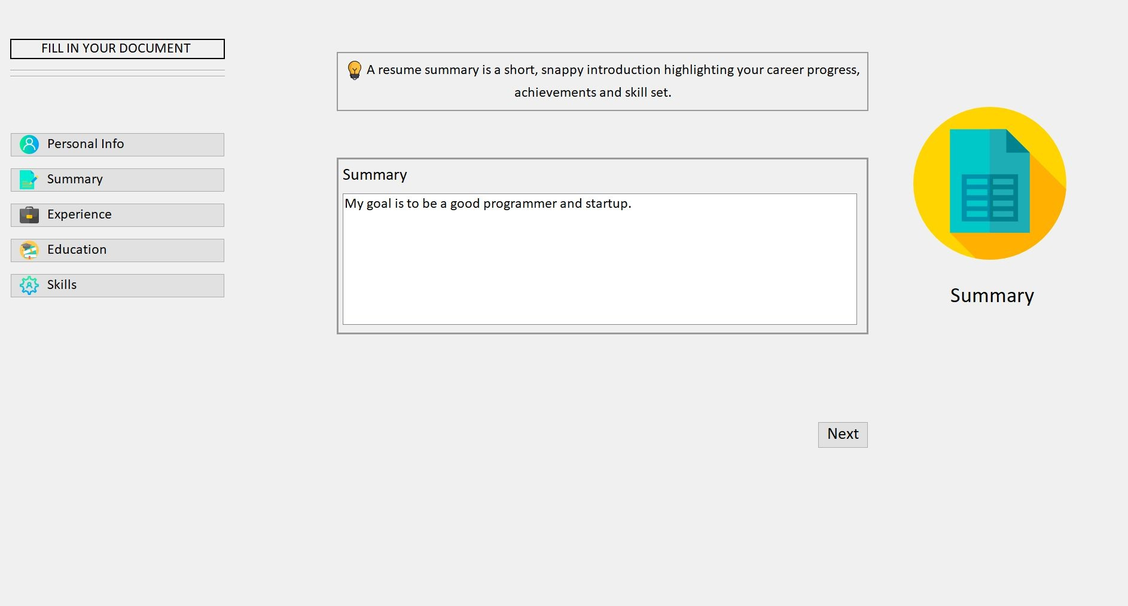**Summary Screen :**

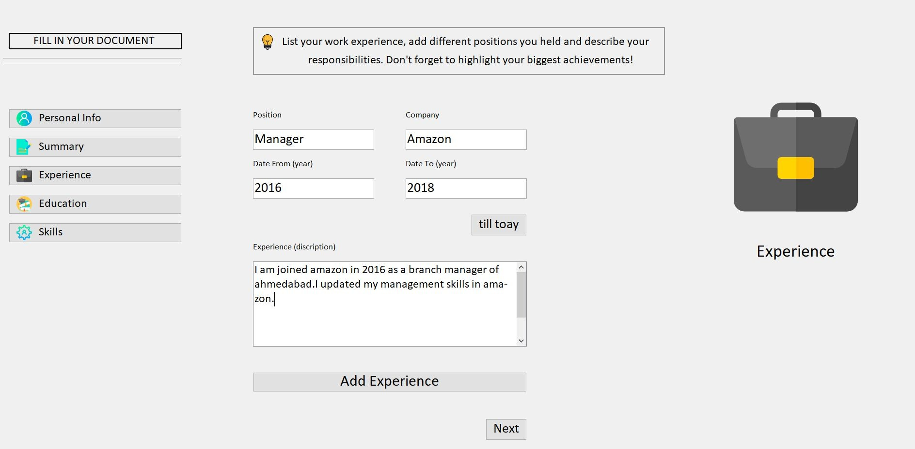**Experience Screen :**

**School Details Screen :**

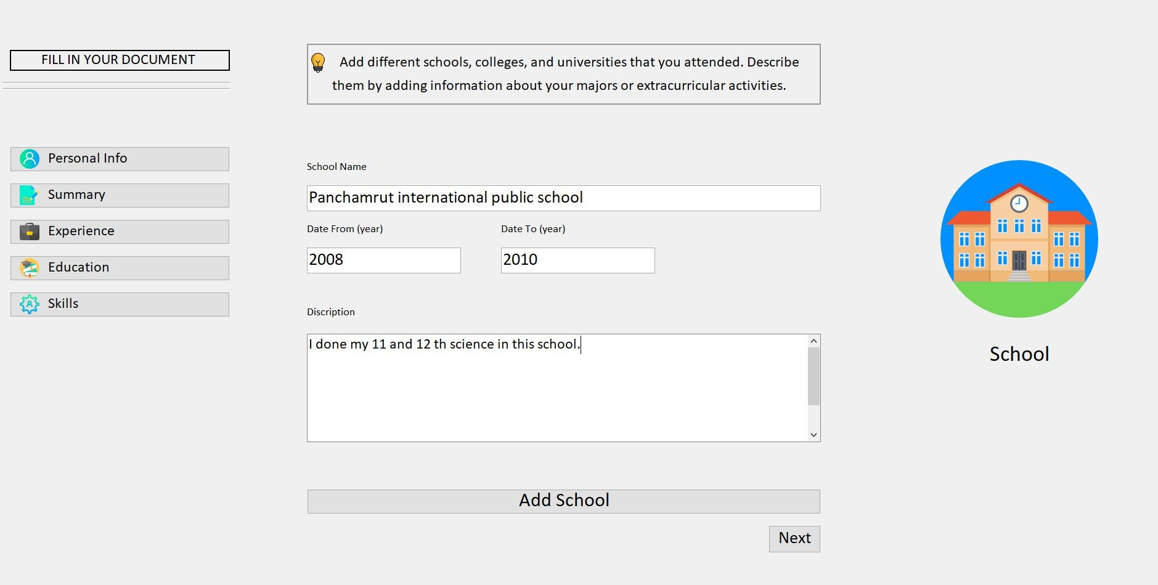

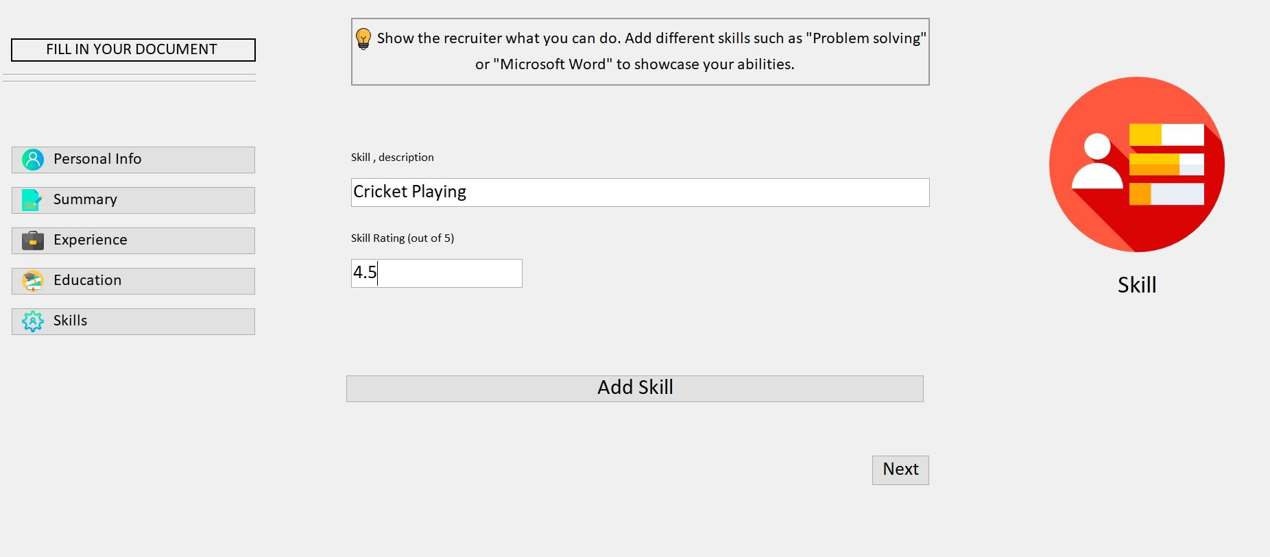**Skill description Screen :**

# Screens for CV Builder

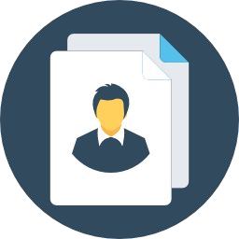

**Personal Information Screen :**

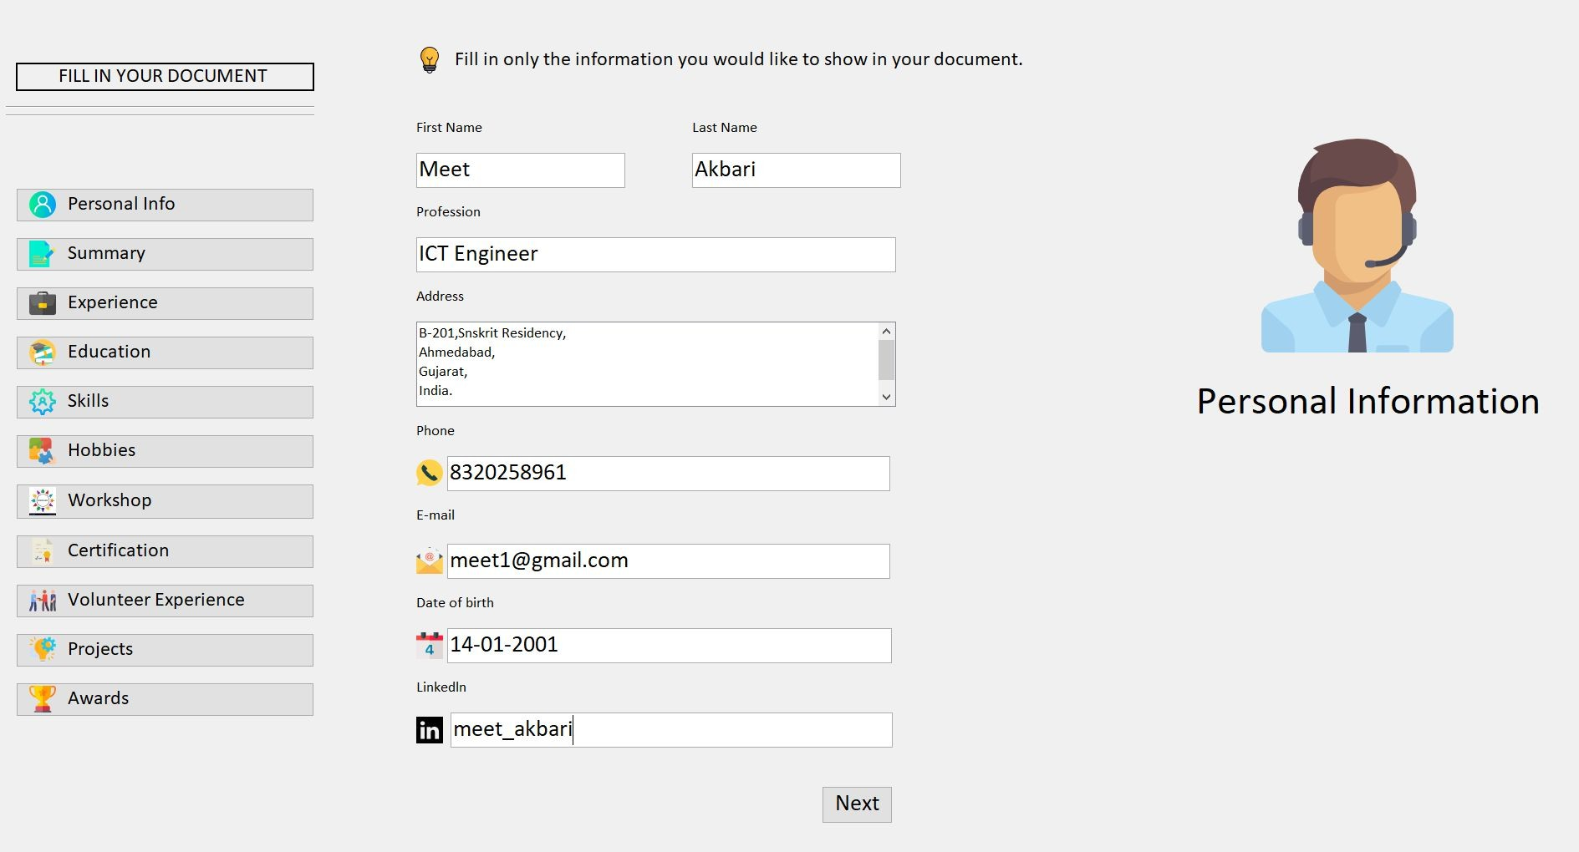

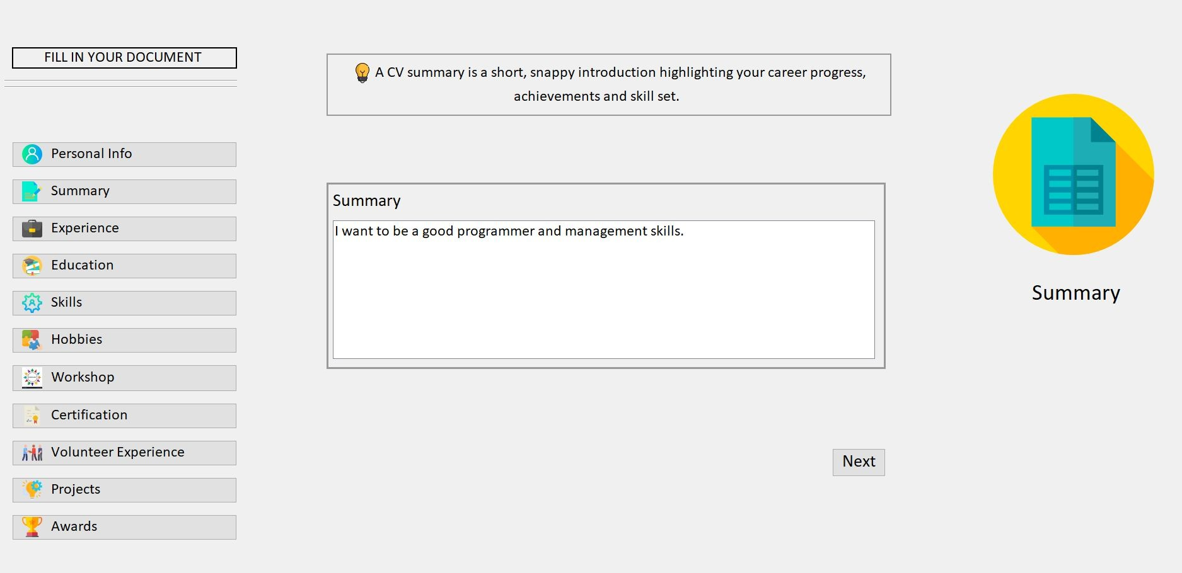**Summary Detail Screen :**

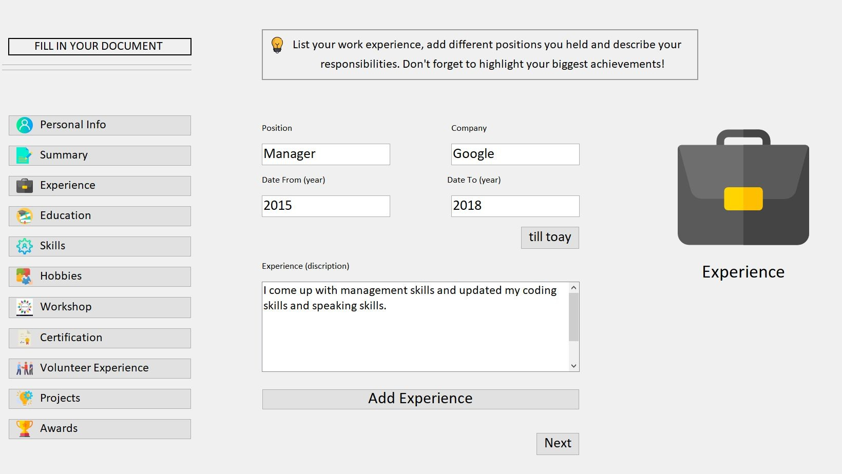**Experience detail Screen**

**School Detail screen :**

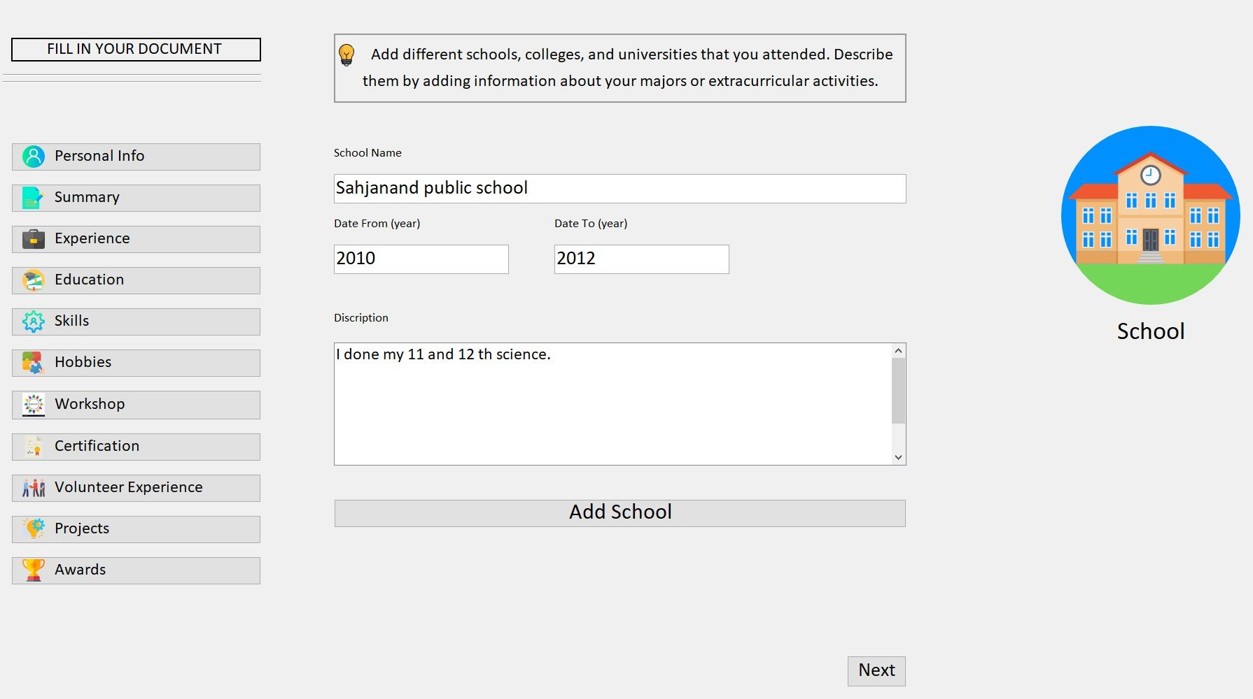

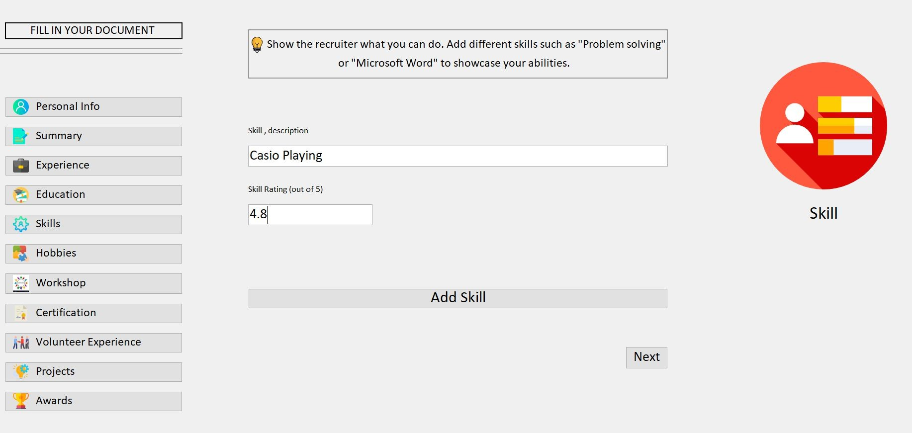**Skill details Screen :**

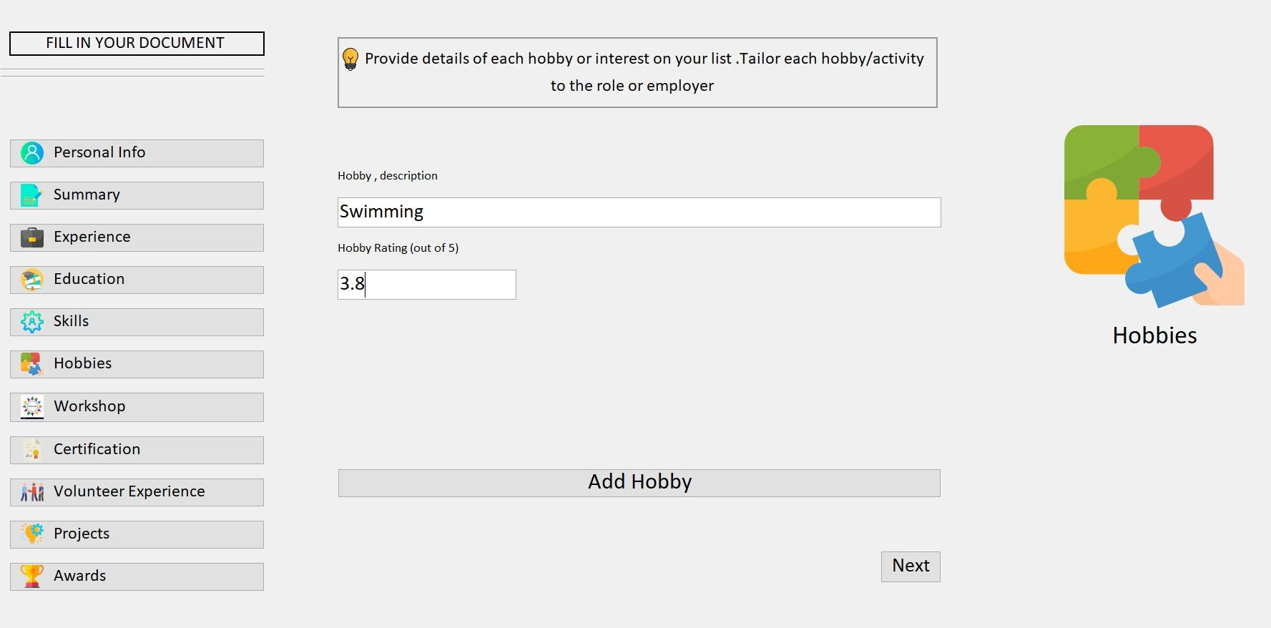**Hobby details Screen :**

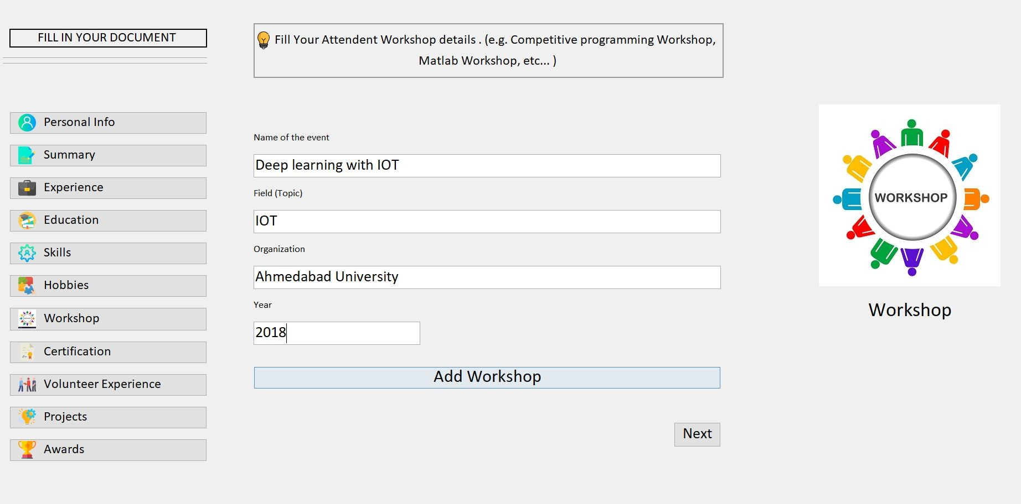**Workshop details Screen :**

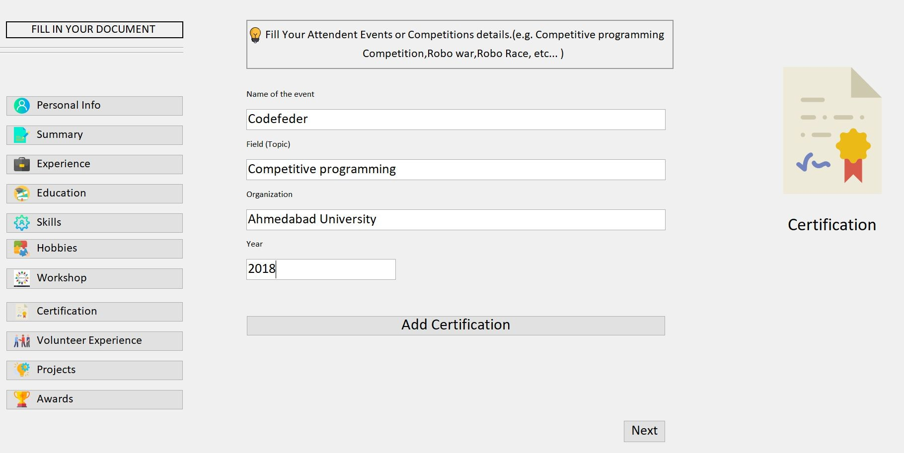**Certification details Screen :**

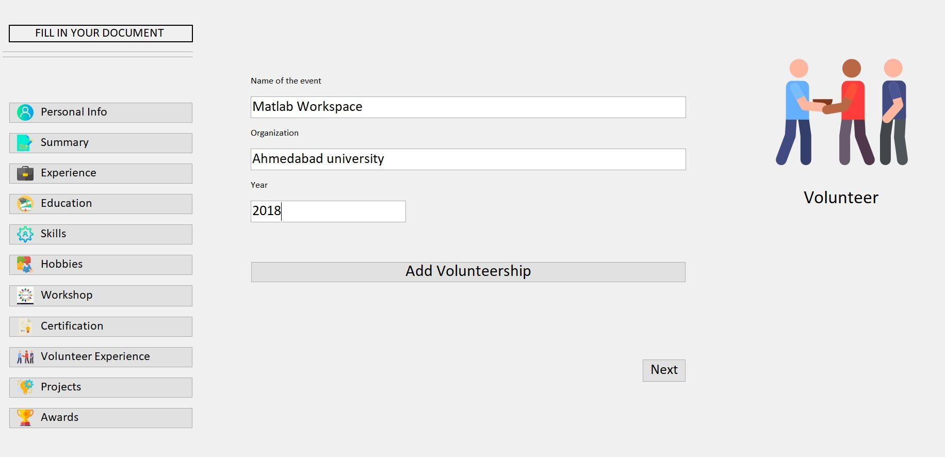**Volunteer experience details Screen :**

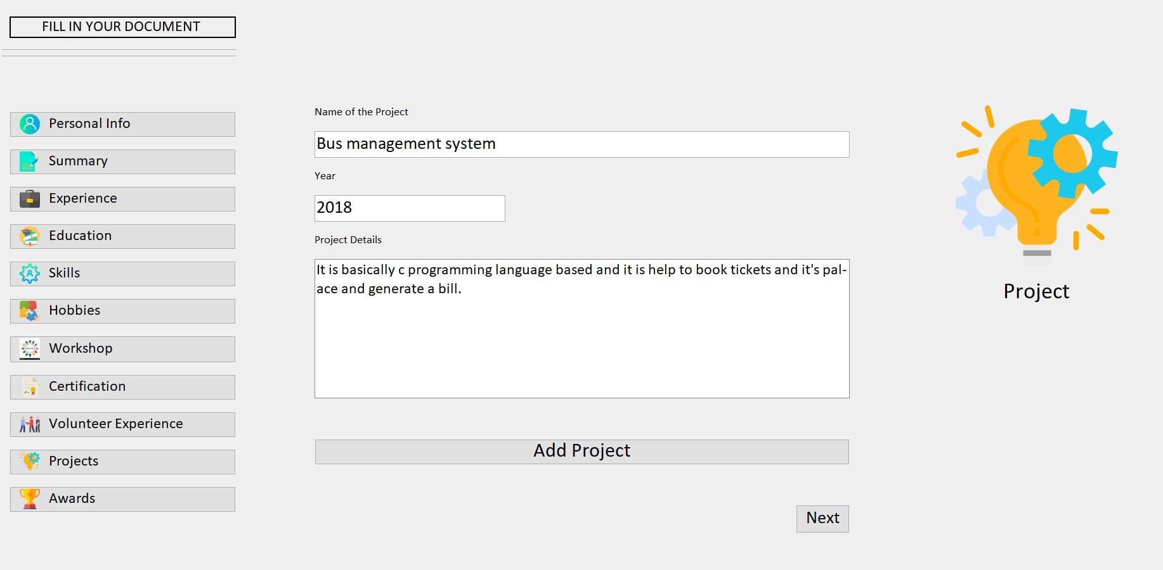**Project details Screen :**

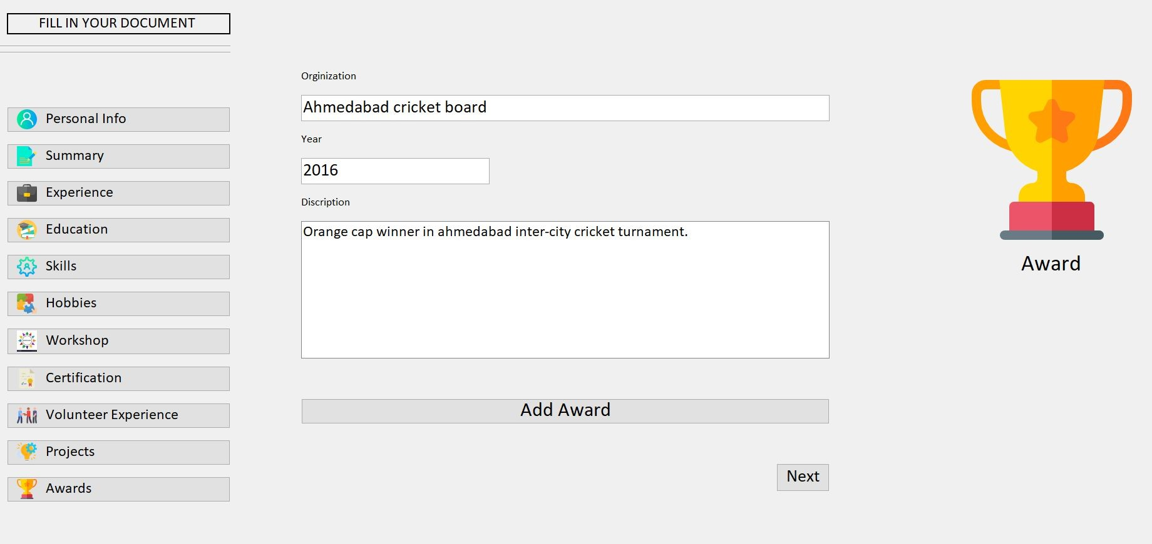**Award details Screen :**

ADMIN Screens

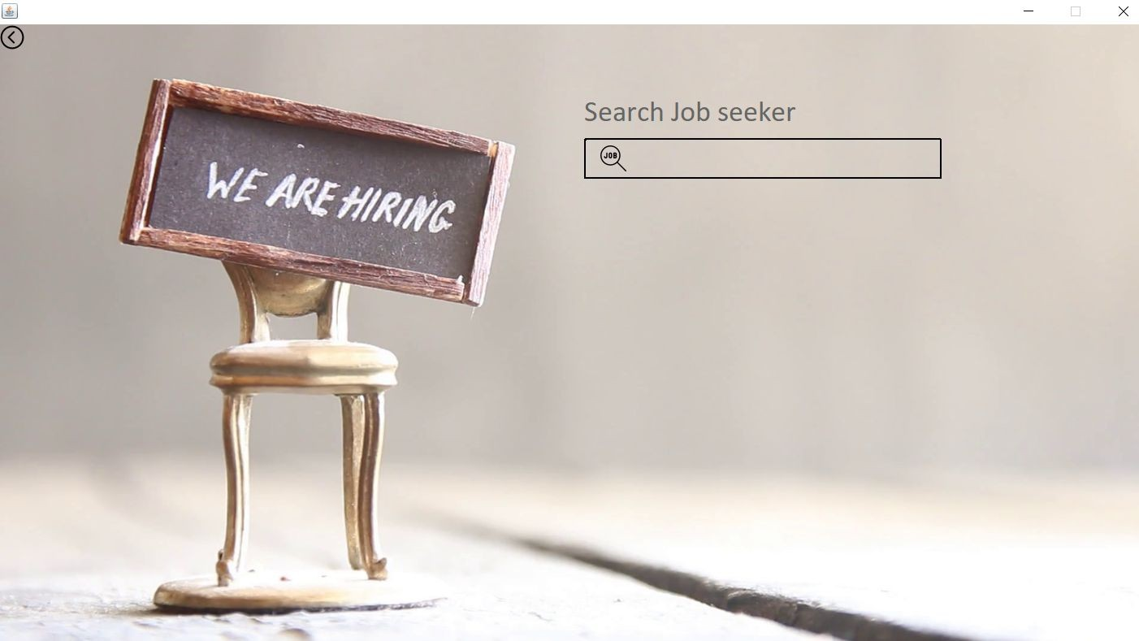

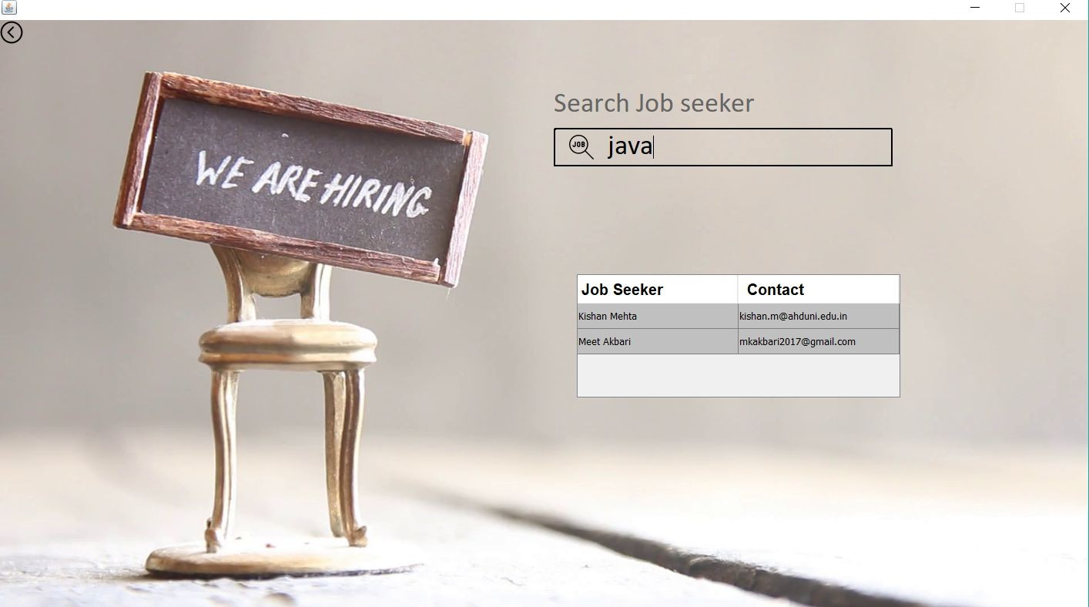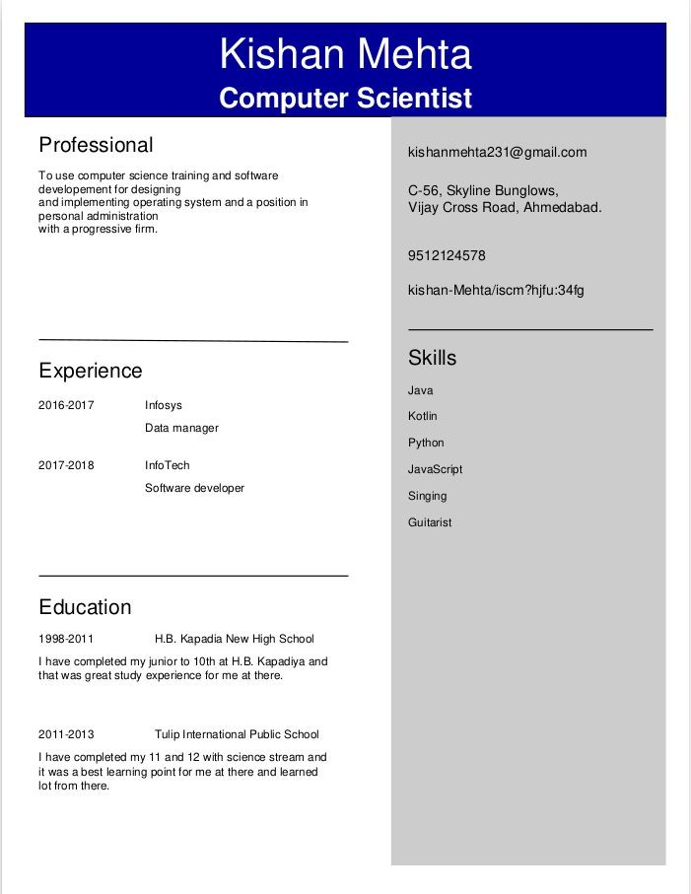

Generated CV looks something like this: